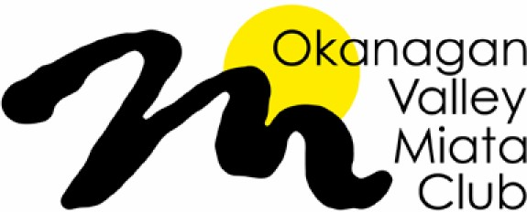 | Membership Application

Personal Information Renewal ______ New Member ______

No need for all information again unless something has changed.

Name:

Spouse / Partner Name:

The OVMC notifies members about upcoming events and news via email and our website. Please provide an email address to receive occasional notices and reminders from the OVMC. You may unsubscribe at any time.

Email Address:

Address:

City: Province: Postal Code:

Home Phone Number: Cell:

Home Phone Number: Cell:

Miata Information

Miata Year / Model: Colour:

Miata Year / Model: Colour:

Membership Roster
Your name, phone and cell numbers, email address, car colour and year will be listed in the membership roster. This Roster will be distributed to Okanagan Valley Miata Club members for their personal use only and will not be used for any other purpose.
- Please check this box, if you do not want to have personal information listed in the membership roster. This means club members will not be able to contact you and you may miss information.

Payment Information
Yearly membership fees are $25 for an individual or couple and cover the period from April 1, 2022 to March 31, 2023. There are three methods of payment:
Cash – paid directly to a director
Cheque – Payable to: Okanagan Valley Miata Club
Address: Okanagan Valley Miata Club, 108 - 197 Dauphin Ave. Penticton BC, V2A 3S3
E-Transfer – Rolly.grimm7@gmail.com

